Nathalia Macedo
77742@student.dorset-college.ie
Abstract
This project develops the SMED Simulator, a Python decision-support tool for analysing and reducing machine setup time. The user records and tags each activity of a changeover; a rules-based recommender, whose rules are stored as editable data, suggests improvement actions and explains each one. A Monte Carlo engine estimates the distribution of machine-stopped time with and without the suggested actions and ranks them by their effect. Data is stored in SQLite, the engine is covered by automated tests, and scheduling across operators is a stretch goal.
Project Report
SMED Simulator: A Decision-Support Tool for Analysing and Reducing Industrial Setup Time



Contents
Project Report 2
1. Introduction 2
2. Research question and objectives 3
3. Design of the simulator 3
User workflow and main screens 3
Software architecture 4
Data model 4
Rules-based recommender 4
Monte Carlo engine 5
Indicators 5
Stretch goal: scheduling across operators 5
Technology 5
Requirements 6
4. Data sources 6
5. Evaluation 6
6. Project plan 7
Risks 7
7. References 8

Project Report

1. Introduction
This project proposes a decision-support tool that analyses an industrial setup, recommends improvement actions and simulates their effect on setup time.
Item | Description
Course | Computer Science, Research Project (Group B)
Student and student number | Nathalia Macedo - 77742
Supervisor | Rod Haanappel
Project title | SMED Simulator: A Decision-Support Tool for Analysing and Reducing Industrial Setup Time
Working software name | SMED Simulator

Context: SMED (Single-Minute Exchange of Die) reduces changeover time by separating internal activities, done with the machine stopped, from external ones, done while it runs, and then converting and streamlining them (Shingo, 1985; Cakmakci, 2009).
Problem: SMED analysis is usually done on paper or in spreadsheets. Spotting which activities can be improved depends on the experience of whoever runs the workshop, each step is given one fixed time, and the effect of an action is only known after it has been implemented.
Proposed solution: a tool that recommends improvement actions from tagged activities, explains each recommendation and simulates its effect on machine-stopped time (Section 3).
Declaration of prior work: The Continental Camaçari study cited as Macedo (2010) is my own Production Engineering dissertation. It is used only as a source of initial rules and as test data. The 2010 analysis is not claimed as a contribution of this project; the contribution is the software.
Contribution to Computer Science: the project has two core components and one stretch goal:
- Rules-based recommender with rules stored as editable data, explanations for each suggestion and automated tests for every rule.
- Monte Carlo simulation engine with three-point duration estimates and reproducible random seeds.
- Stretch goal: scheduling activities across operators with precedence constraints, shown as a Gantt chart.
These sit on a relational data model (SQLite with SQLAlchemy) and are developed with test-driven practices.

2. Research question and objectives
Research question: How can a computer simulator support decision-making when identifying and transforming setup activities according to the SMED methodology?
Specific objectives:
- Design a relational data model for processes, activities, rules, scenarios and simulation runs.
- Implement a rules-based recommender that identifies improvement opportunities from activity tags and attributes and explains each suggestion.
- Implement a Monte Carlo engine that estimates the distribution of machine-stopped time for each scenario.
- Rank suggested actions by their simulated effect and convert minutes saved into extra output.
- Develop a Streamlit interface for data entry, rule editing, scenario comparison and results.
- Verify the software with automated tests and evaluate its predictions, as far as the available data allows.
- Stretch goal: schedule activities across operators and display the result as a Gantt chart.

3. Design of the simulator

User workflow and main screens
Figure 1 shows how an engineer uses the tool. (1) The user records the process and its activities, with type, three-point durations and tags. (2) The recommender lists suggestions ranked by simulated saving, each with the rule that produced it and the reason; the user accepts, edits or rejects them. (3) The accepted suggestions form a scenario, and the Monte Carlo engine compares it with the baseline. (4) A timeline shows which activities were moved outside the stop or shortened; with the stretch goal it becomes a Gantt chart by operator.
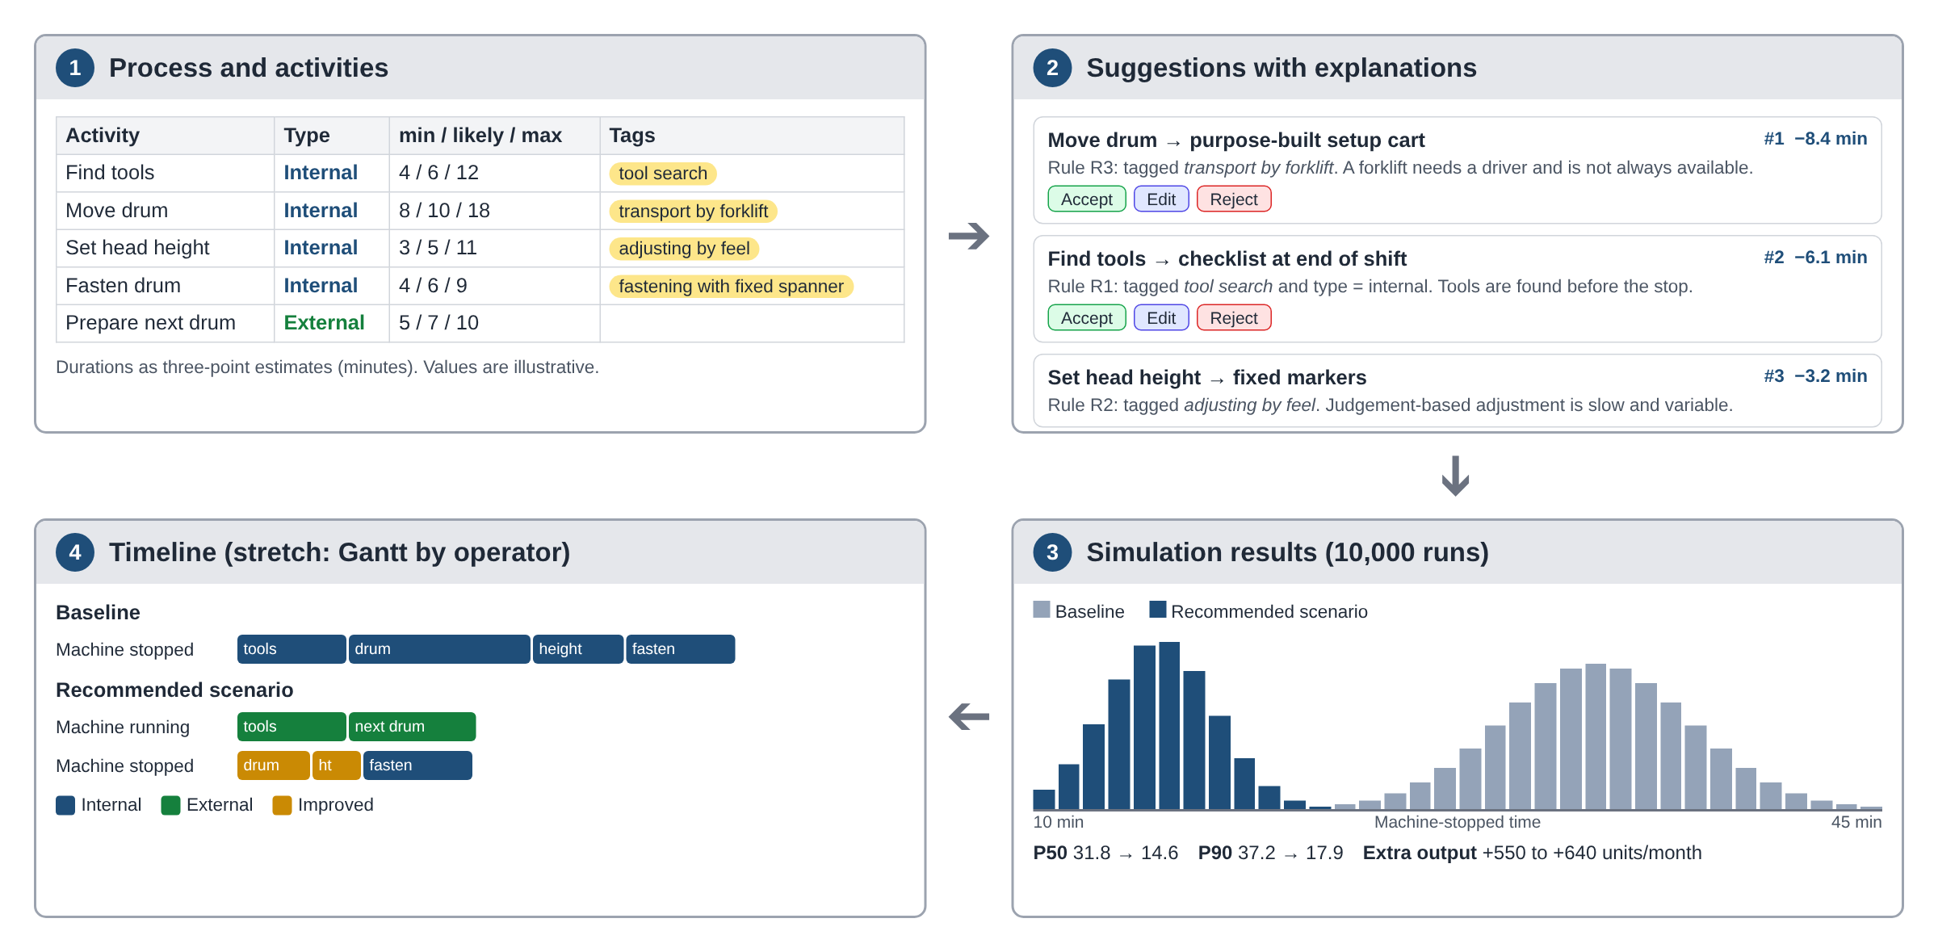
Figure 1: Main screens and user workflow (wireframe; values are illustrative).

Software architecture
The code is organised in four layers. Dependencies point in one direction only (interface, services, domain), and services reach the database only through repositories, so the engine can be tested with an in-memory SQLite database and no interface.
Layer | Responsibility | Example modules
Interface | Streamlit pages for data entry, rule editing, scenarios and results | pages/activities.py, rules.py, results.py
Services | Recommender, Monte Carlo simulation, metrics, scheduler (stretch) | services/recommender.py, simulation.py, metrics.py
Domain | Activity, Rule, Suggestion and Scenario classes; condition interpreter | domain/
Persistence | SQLAlchemy models and repositories over SQLite | database/models.py, repositories.py

Data model
Entity | Main attributes
Process | id, name, machine, setups per month, production rate (units per minute)
Activity | id, process_id, name, type (internal or external), t_min, t_likely, t_max, operators, tools, predecessors
Tag / ActivityTag | tag name; many-to-many link between activities and tags
Rule | id, tag, condition (attribute, operator, value), suggested action, default effect, rationale, active
Suggestion | activity_id, rule_id, explanation, simulated saving, status (accepted, edited, rejected)
Scenario / ScenarioAction | scenario details; action applied to each activity and its new durations
SimulationRun | scenario_id, iterations, random seed, mean, P10, P50, P90, run date

Rules-based recommender
The recommender follows the structure of a rule-based system (Jackson, 1999). Rules are data, not code: each rule is a row in the Rule table with a tag, a condition, a suggested action, a default effect and a rationale. Conditions are stored as attribute, operator and value (for example type = internal, or t_likely ≥ 3) and evaluated by a small interpreter, so rules can be added or changed in the interface without editing the program. The initial rule set is taken from the Camaçari workshop:
Tag | Condition | Suggested action | Rationale
tool search | type = internal | Tool checklist checked at the end of each shift (convert to external) | Tools are found before the machine stops, not during the stop
adjusting by feel | type = internal | Fixed markers for each product size (standardize) | Judgement-based adjustment is slow and variable
transport by forklift | any | Purpose-built setup cart (reduce) | A forklift needs a driver, is not always available and is unstable
fastening with fixed spanner | type = internal | Ratchet spanner or wing nuts (reduce) | Fastening is a major source of internal time (Shingo, 1985)
parameter check | type = internal | Visual indicator of the correct value (reduce) | Unclear values lead to errors and rework
infrequent procedure | any | One-point lesson at the machine (standardize) | Operators do not have to rely on memory

For each activity, the recommender selects the active rules whose tag matches and whose condition is true. Each suggestion carries an explanation in the form "Suggested because activity X is tagged tool search and is internal (rule R1): tools are found before the machine stops." The engine then applies each suggestion’s default effect, runs the Monte Carlo simulation and ranks the suggestions by the reduction in median machine-stopped time. The highest-ranked suggestions form a recommended scenario, which the user can accept, edit or reject. This is the decision the tool supports: which actions to implement first, and what effect to expect.

Monte Carlo engine
For each activity the user enters a minimum, most likely and maximum duration, as in PERT (Malcolm et al., 1959). In each iteration the engine samples one duration per activity from a triangular distribution (Vose, 2008) and adds the internal activities, which gives the machine-stopped time. Repeating this 10,000 times with a fixed seed produces a reproducible distribution for each scenario (Law, 2015), summarized by the mean and the P10, P50 and P90 values.

Indicators
For each run the engine calculates internal time T_int = Σ t_i (internal activities), external time T_ext = Σ t_i (external activities), the reduction R = T_int,before − T_int,after and R% = R / T_int,before × 100. Production impact is setups per month × R × production rate, shown as a range. Converting an internal activity to external does not reduce the total work; it moves that work outside the stop. The main indicator is therefore machine-stopped time (T_int), with total work (T_int + T_ext) shown alongside, so that a scenario cannot appear better simply by moving time from one column to the other.

Stretch goal: scheduling across operators
Without scheduling, machine-stopped time is the sum of internal activities, which assumes a single operator. The stretch goal replaces the sum with list scheduling (Kolisch, 1996): activities are assigned to operators in priority order while respecting predecessors, and the stopped time becomes the makespan of the internal activities, shown as a Gantt chart. The data model already stores operators and predecessors, so this extension needs no database changes.

Technology
Layer | Technology
Language | Python
Interface | Streamlit
Data and simulation | Pandas and NumPy
Database and ORM | SQLite with SQLAlchemy
Charts | Plotly
Testing | Pytest with pytest-cov
Version control | Git and GitHub

Requirements
Functional requirements
- FR1: Create, edit and delete processes, activities and tags.
- FR2: Create, edit, activate and deactivate rules without changing the code.
- FR3: Generate suggestions for a process, each with an explanation naming the rule and the matched attributes.
- FR4: Rank suggestions by simulated reduction in median machine-stopped time.
- FR5: Accept, edit or reject each suggestion to build a scenario.
- FR6: Run a Monte Carlo simulation with a chosen number of iterations and seed.
- FR7: Show histograms, P10/P50/P90, before and after comparison and production impact.
- FR8: Save all data in SQLite and export results to CSV.
- FR9 (stretch): Schedule internal activities across operators and show a Gantt chart.

Non-functional requirements
- NFR1: 10,000 iterations for 30 activities run in under 5 seconds on a standard laptop.
- NFR2: Results are reproducible with the same seed.
- NFR3: The engine is independent of the interface; every rule has at least one Pytest test.
- NFR4: Inputs and rule conditions are validated before use (t_min ≤ t_likely ≤ t_max).
- NFR5: An engineer with no programming knowledge can use the tool, including editing rules.

4. Data sources
Continental Camaçari (prior work): a three-day SMED workshop on the BAC machine reduced setup time from 67 to 17 minutes (Macedo, 2010). The study recorded only these totals, so step-level timings are not available. Camaçari is therefore used to seed the initial rules and to check the correctness of the calculations, not to test predictions.
Fashionflo (not yet confirmed): a Dublin printing company whose press job changes (plates, ink, settings) are typical SMED changeovers. Data collection depends on written permission from the company, informed consent from staff and college ethics approval. If it does not take part, the project uses Camaçari plus synthetic scenarios and states the limits of the evaluation in CA3.

5. Evaluation
Checking the code and testing the predictions are kept separate.
- Verification (checking the code): Pytest tests for the data model, the condition interpreter, every rule, the Monte Carlo engine and the impact model, with at least 80%-line coverage of the engine. A deterministic run with the Camaçari totals must reproduce 67 and 17 minutes and the 1,660 tyres per month. This shows the arithmetic is correct; it does not show that the tool predicts anything.
- Prediction (testing the model): at Fashionflo, an engineer gives three-point estimates for each activity and for the effect of each action before the changes are made. The simulated P50 is then compared with a real re-measurement, reporting the error and whether the measured time falls between P10 and P90.
- Recommender: because the initial rules come from Camaçari, testing them on Camaçari would be circular. At Fashionflo, the suggestions will be compared with the actions the engineer proposes independently, and the engineer will rate the usefulness of each explanation.
If Fashionflo is not available, only verification will be possible, and CA3 will say so.

6. Project plan
Milestone | Deliverable | Target date
CA1: Project proposal | This report | 01/11/2026
M1: Case study decision | Fashionflo visit and permissions, ethics application, or switch to the fallback | 30/11/2026
M2: Design | Database schema, architecture, rule table format, test plan, wireframes | 18/12/2026
M3: Engine core | SQLite data layer and Monte Carlo engine with tests | S2 Week 1
M4: Recommender | Condition interpreter, rules, explanations, ranking, tests | S2 Week 3
M5: Interface | Registration, rule editing, scenario builder, results | S2 Week 5
M6: Data collection | Fashionflo estimates before changes; re-measurement after | S2 Weeks 4–7
M7: Stretch goal | Operator scheduling and Gantt chart | S2 Week 7
CA2: Software application | Working application, tests and coverage report | S2 Week 8
Evaluation complete | Verification, prediction and recommender results | S2 Week 8
CA3: Written report | Design decisions, algorithms, testing and evaluation | S2 Week 10
CA4: Presentation | Final presentation and demonstration | S2 Week 11

Risks
Risk | Likelihood | Mitigation
Fashionflo does not confirm or withdraws | High | Decide by 30/11; use Camaçari and synthetic scenarios and limit the evaluation to verification
No step-level data for Camaçari | Certain | Use Camaçari only for rules and correctness checks; do not claim predictive accuracy from it
Rules from one case do not generalize | Medium | Rules are editable data; review them with the Fashionflo engineer
Ethics approval is delayed | Medium | Apply in November; no observation of staff before approval
Limited time alongside work and other modules | Medium | Build the two core components first; start the stretch goal only after M5

7. References
Cakmakci, M. (2009) ‘Process improvement: performance analysis of the setup time reduction-SMED in the automobile industry’, The International Journal of Advanced Manufacturing Technology, 41(1–2), pp. 168–179.
Jackson, P. (1999) Introduction to expert systems. 3rd edn. Harlow: Addison-Wesley.
Kolisch, R. (1996) ‘Serial and parallel resource-constrained project scheduling methods revisited: theory and computation’, European Journal of Operational Research, 90(2), pp. 320–333.
Law, A.M. (2015) Simulation modeling and analysis. 5th edn. New York: McGraw-Hill Education.
Macedo, N.F. (2010) A importância da ferramenta SMED para o aumento de produtividade: estudo de caso na fábrica Continental de Camaçari [The importance of the SMED tool for increasing productivity: a case study at the Continental factory in Camaçari]. Bachelor’s dissertation (Production Engineering). Salvador: Faculdade Área1.
Malcolm, D.G., Roseboom, J.H., Clark, C.E. and Fazar, W. (1959) ‘Application of a technique for research and development program evaluation’, Operations Research, 7(5), pp. 646–669.
Shingo, S. (1985) A revolution in manufacturing: the SMED system. Cambridge, MA: Productivity Press.
Vose, D. (2008) Risk analysis: a quantitative guide. 3rd edn. Chichester: Wiley.

